Arrays, Strings, Sets, Maps – Exercises
Exercises and homework assignments for “Introduction to Programming with AI” course at SoftUni.
Judge submission link: https://alpha.judge.softuni.org/contests/arrays-strings-sets-maps-exercises/5280/.

Plus / Minus Sum
Create a JavaScript function, which takes as input an array of numbers and sums the numbers, by adding numbers at odd positions and subtracting numbers at even positions. Examples:
- [5, 10, 3] 5 + 10 - 3 = 12
- [5, 15, 23, 56, 35, 3] 5 + 15 - 23 + 56 – 35 + 3 = 21

Input and Output
Input comes as array of numbers. Print the output on the console in the below format:
Input | Output
plusMinusSum([5, 10, 3]); | 5 + 10 - 3 = 12
plusMinusSum([5, 15, 23, 56, 35, 3]); | 5 + 15 - 23 + 56 – 35 + 3 = 21
plusMinusSum([5]); | 5 = 5

Hints
First, create a folder to keep all your code from this exercise and open it in Visual Studio Code. Give it a reasonable name, e.g. “Arrays-Strings-Sets-Maps”:
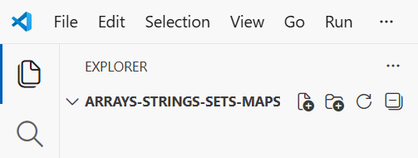
Next, create a JS file to hold the code for this problem. Give it a reasonable name, e.g. "plus-minus-sum.js":
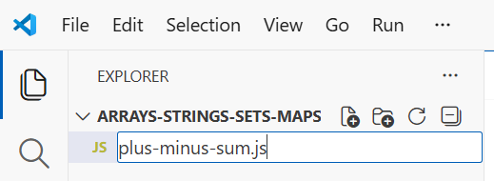
Now, declare the function, with its input parameters and invoke it with a sample input data:
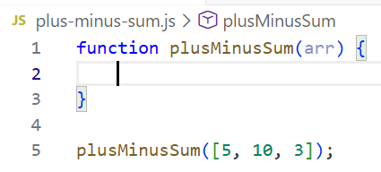
Now, it's time to write the code. Either ask the AI assistant to implement the function or write it yourself:
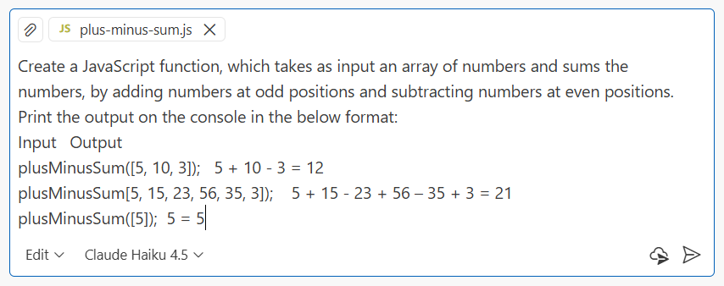
This is a sample solution:
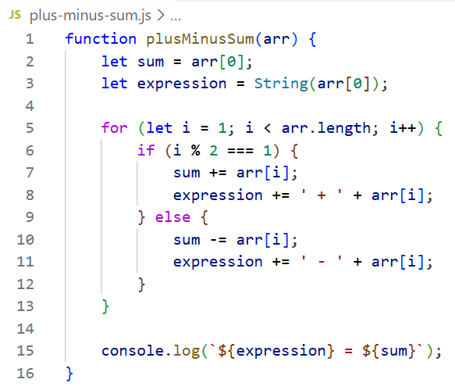

Judge Submission
Submit your code to the judge: https://alpha.judge.softuni.org/contests/arrays-strings-sets-maps-exercises/5280/.

Add / Subtract Array
Create a JavaScript function that modifies the values of odd and even numbers in an array of integers. The function should perform the following operations:
- For even numbers, add their index position to their value.
- For odd numbers, subtract their index position from their value.

Input and Output
Input comes as array of integers. Output should be printed on the console:
- At the first line, print the modified array.
- At the second line, print the sum of the numbers from the original array.
- At the third line, print the sum of the numbers from the modified array.
Follow the output format from the examples below:
Input | Output | Comments
addSubtractArray(  [5, 15, 23, 56, 35]); | [ 5, 14, 21, 59, 31 ]  Sum original: 134  Sum modified: 130 | [5-0, 15-1, 23-2, 56+3, 35-4]
addSubtractArray(  [-5, 11, 3, 0, 2, 4]); | [ -5, 10, 1, 3, 6, 9 ]  Sum original: 15  Sum modified: 24 | [-5-0, 11-1, 3-2, 0+3, 2+4, 4+5]

Hints
Create a new JS file, which will hold your code. Give it a reasonable name, e.g. “Add-and-Subtract.js”:
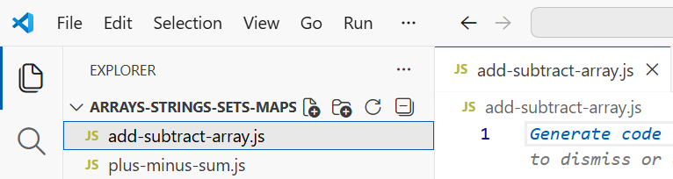
Now, define the function addSubtractArray(arr). Start with the function declaration:
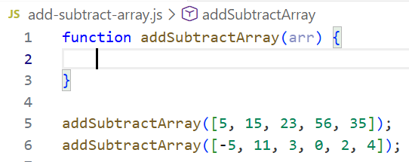
The next step is to write the function body. This is a sample implementation:
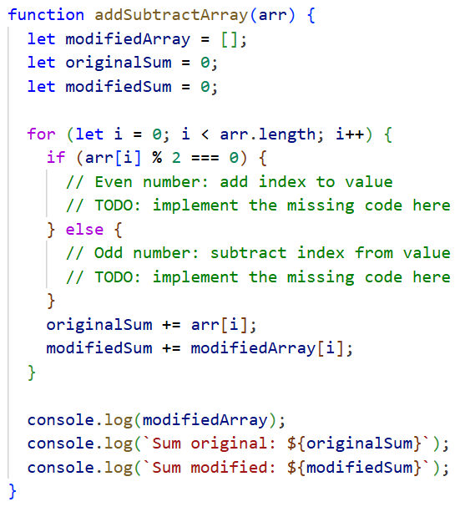

Judge Submission
Submit your code to the judge: https://alpha.judge.softuni.org/contests/arrays-strings-sets-maps-exercises/5280/.
Note: you can submit to the judge only a single JS function. In case you have several functions, move some of them as inner functions, and finally submit only one function, holding the others.

Handle Incorrect Input
Ask the AI assistant to add relevant checks of the input data. Use a simple prompt in GitHub Copilot:
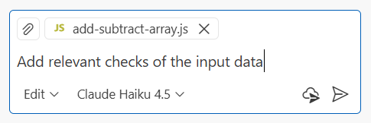
This is a sample code, implementing input data validation:
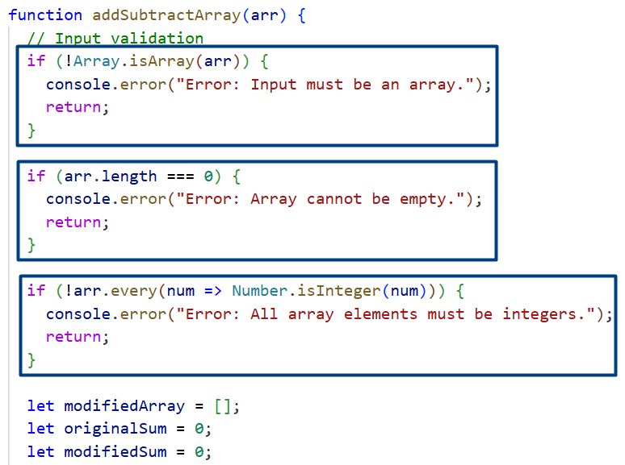

Partial Reverse of Array
Write a JS function that takes a number n and an array of elements as input. Your task is to create a new array holding the first n elements from the original array, in reversed order. Print the output array elements on a single line, separated by spaces.

Input and Output
Input | Output
partialReverseArray(3, [10, 20, 30, 40, 50]); | 30 20 10
partialReverseArray(4, [-1, 20, 99, 5]) | 5 99 20 -1
partialReverseArray(2, ["one", "two", 3, 4, 5]); | two one

Hints
Iterate through the first n elements of the array and use unshift() to prepend elements in the new array. This is a sample implementation:
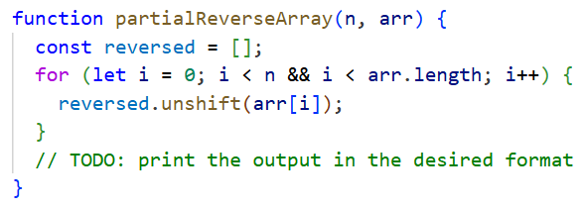

Rewrite without unshift()
Try asking Copilot to rewrite the code without unshift(). Use the prompt box to write the prompt:
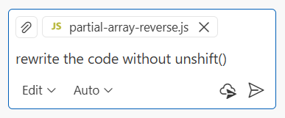
As we can see, Copilot might decide to use slice() and reverse() instead of the loop iteration.
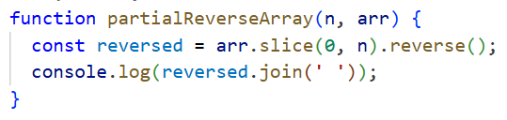

Judge Submission
Submit your code to the judge: https://alpha.judge.softuni.org/contests/arrays-strings-sets-maps-exercises/5280/.

Top Elements
Write a JavaScript function that identifies all the "top elements" in an array of numbers. A top element is defined as an element that is greater than all the elements to its right.

Input and Output
The input comes as array of numbers. The output is an array of numbers, sorted increasingly.
Input | Output
console.log(extractTopElements([1, 4, 3, 2])); | [ 2, 3, 4 ]
console.log(extractTopElements([14, 24, 3, 19, 15, 17])); | [ 17, 19, 24 ]
console.log(extractTopElements([41, 41, 34, 20])); | [ 20, 34, 41 ]
console.log(extractTopElements([27, 19, 42, 2, 13, 45, 48])); | [ 48 ]

Hints
The simplest algorithm is to scan the numbers from left to right in a loop and check each number if all numbers after it are smaller (with another loop). This will cost two nested loops + sort (or reverse).
Alternatively, you can write a faster algorithm (with a single loop): scan from right to left and for each position visited, calculate the greatest element from it to the end. Sorting will not be needed in this case, because the numbers will come in increasing order.

Judge Submission
Submit your code to the judge: https://alpha.judge.softuni.org/contests/arrays-strings-sets-maps-exercises/5280/.

Balancer Element
A "balancer element" inside an array is an element, such that the sum of all elements on left of it is equal to the sum of all elements on the right of it.
Write a JS function that checks whether there exists a balancer element inside given array of numbers.

Input and Output
The input comes as array of numbers. The output is the index of the balancer element when it exists or "no" otherwise. Print the output at the console.
Input | Output | Comments
findBalanceIndex([1, 2, 3, 3]); | 2 | At a[2] -> left sum=3, right sum=3  a[0] + a[1] = a[3]
findBalanceIndex([1, 2]); | no | At a[0] -> left sum=0, right sum=2  At a[1] -> left sum=1, right sum=0  No such index exists
findBalanceIndex([1]); | 0 | At a[0] -> left sum=0, right sum=0
findBalanceIndex([1, 2, 3]); | no | No such index exists
findBalanceIndex([10, 5, 5, 99, 3, 4, 2, 5, 1, 1, 4]); | 3 | At a[3] -> left sum=20, right sum=20  a[0] + a[1] + a[2] = a[4] + a[5] + a[6] + a[7] + a[8] + a[9] + a[10]

Hints
If you are unsure of the correct prompt, copy the problem description together with the provided input + output examples in the table and use them as a prompt to Copilot. This is how the prompt may look like:
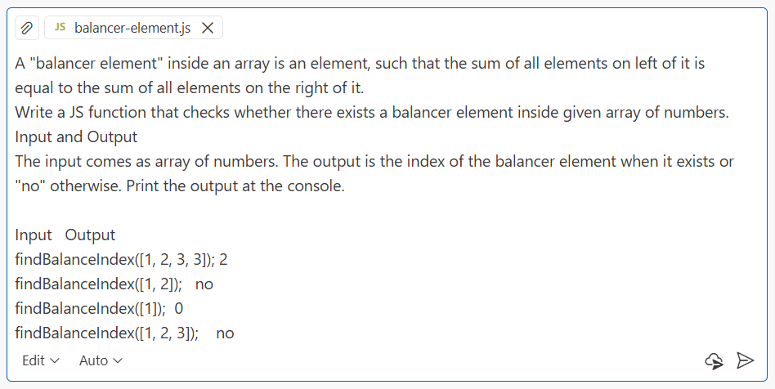
This is a sample implementation, generated by the above prompt:
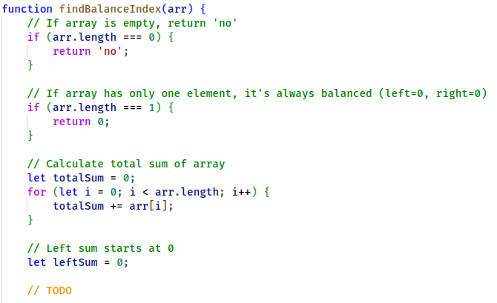
Explaining the Code
Select a code snippet and ask Copilot to explain it. Select the snippet with the mouse cursor (or with keyboard selection), then right click and select [Add Selection to Chat] from the popup menu:
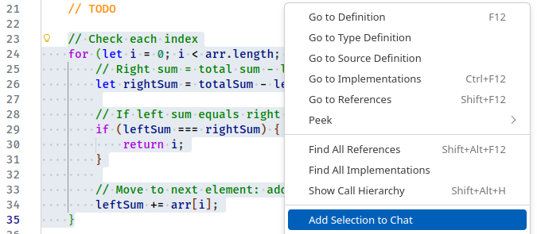
The code snipped will be added as a context to the prompt:
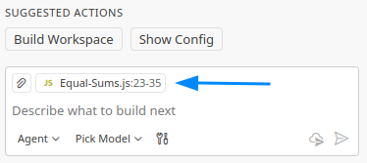
Ask Copilot to explain the code in the selected snipped. For example:
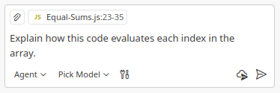

Judge Submission
Submit your code to the judge: https://alpha.judge.softuni.org/contests/arrays-strings-sets-maps-exercises/5280/.

Implement HTML Balancer Visualizer
Using GitHub Copilot, let's implement an HTML editor `balancer.html`, holding 3 columns:
- Numbers on the left side: list box with add / remove functionality
- Middle element
- Numbers on the right side: list box with add / remove functionality
After changing any of the input data, visualize the balance visually, as a weighting scale.
This is a sample implementation of the visualizer:
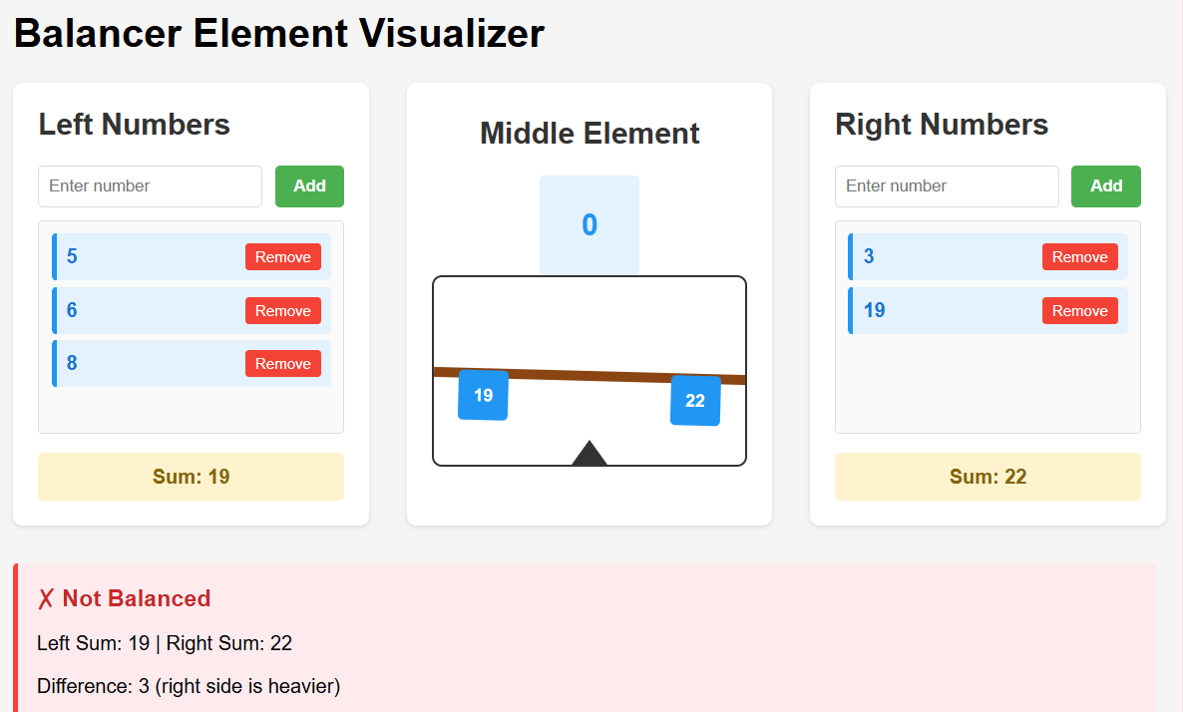

Sort Products
Create a JavaScript function that takes an array of product names and prints on the console a numbered list of all the products sorted by name.

Input and Output
The input comes as array of strings. The output is a multi-line string.
Input | Output
console.log(sortProducts(['Potatoes', 'Tomatoes', 'Onions', 'Apples'])); | 1.Apples  2.Onions  3.Potatoes  4.Tomatoes
console.log(sortProducts(['Watermelon', 'Banana', 'Apples'])); | 1.Apples  2.Banana  3.Watermelon

Hints
- Tell Copilot to use the sort() function to rearrange the array in ascending order.
- And finally, to print the sorted array: “loop through the array”.
This is a sample solution:
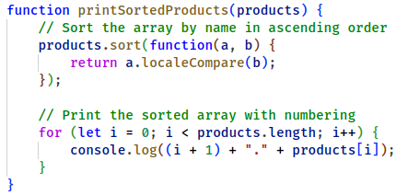

Implement HTML Formatting
Add an optional second parameter formatAsHTML = false to your function, to specify if the output should be text or HTML. Your JS function should work like this:
Input | Output
console.log(sortProducts(['Potatoes', 'Tomatoes', 'Onions', 'Apples'])); | 1.Apples  2.Onions  3.Potatoes  4.Tomatoes
console.log(sortProducts(['Potatoes', 'Tomatoes', 'Onions', 'Apples'], true)); | <ol>  <li>Apples</li>  <li>Onions</li>  <li>Potatoes</li>  <li>Tomatoes</li>  </ol>

Visualization as HTML
Create an HTML page to visualize and use your function sortProducts(products, formatAsHTML).
Write a prompt in GitHub Copilot to describe what you want to achieve: a HTML page to enter products (comma separated), then sort them with a button click using the existing function and visualize the output as HTML numbered list. Here are sample results:
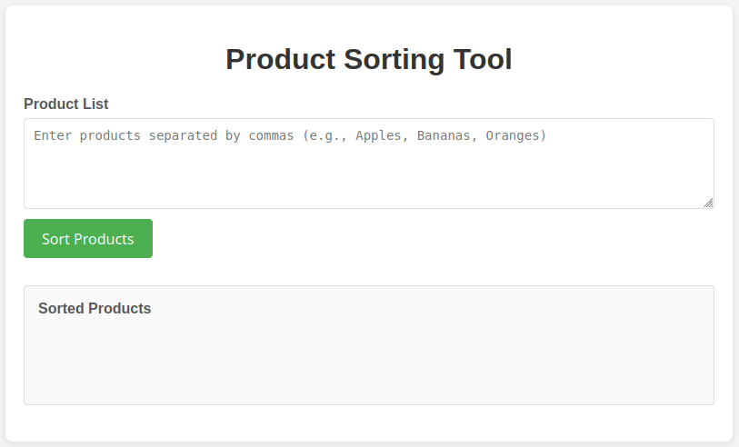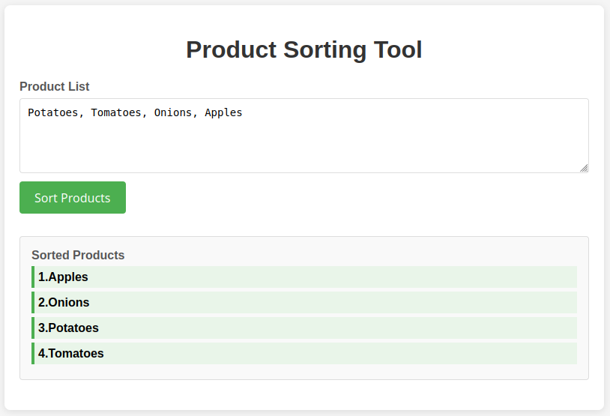

Judge Submission
Submit your code to the judge: https://alpha.judge.softuni.org/contests/arrays-strings-sets-maps-exercises/5280/.

Word Occurrences
Write a JavaScript function that counts the occurrences of each word in given text. Print the words sorted by their counts in descending order, and alphabetically as a second criteria. The input will be provided as an array of strings.

Input and Output
The input text comes as string. It holds sentences, separated by sentence delimiters like ".", "!" and "?". Sentences consist of sequences of words. Words are separated by non-letter characters (like space, comma and others).
The output consists of pairs of {word, count} printed in format "{word} -> {x} times". Words are always counted and printed in lowercase. Order the output by count (descending), then by word (alphabetically). Print the output to the console.
Input | Output
countWordOccurences("Here is the first sentence. Here is another sentence. And finally, the third sentence."); | sentence -> 3 times  here -> 2 times  is -> 2 times  the -> 2 times  first -> 1 times  another -> 1 times  and -> 1 times  finally -> 1 times  third -> 1 times

Hints
Instruct Copilot to follow your instructions:
- Split the input text into words (lowercase).
- Create a map: {word --> count}.
- Loop through the array of words.
- Update the word counts map for each word occurrence.
- Convert the map to array, then sort it by value in descending order, then by key in ascending order.
- Finally, print the result at the console.
Step-by-step prompting is considered and widely proved to provide better and more consistent results.
The modular approach and consecutive steps improve model performance and produce less errors.
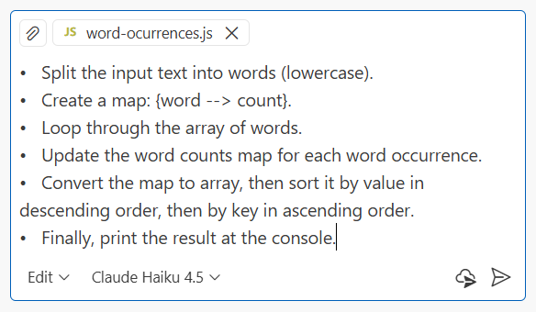

Visualization as HTML
Create an HTML page to visualize the word count.
Ask Copilot to create a histogram in HTML + CSS + JS and use your code as a data source.
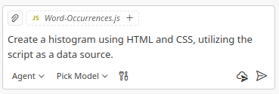
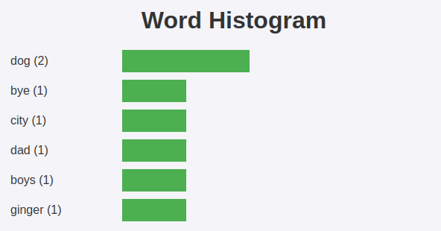
Experiment further with different styles, figures and even a page/app that accepts the string arrays dynamically.

Judge Submission
Submit your code to the judge: https://alpha.judge.softuni.org/contests/arrays-strings-sets-maps-exercises/5280/.

Array Manipulations
Write a function that manipulates an array of numbers with the following commands:
- Add {number}: Adds a number to the end of the array.
- Remove {number}: Removes all occurrences of a specified number from the array.
- RemoveAt {index}: Removes the number at the given index.
- Insert {number} {index}: Inserts a number at the specified index.
Note: All indices will be valid!

Input and Output
The input will be provided as an array of strings.
- The first element will hold the array of numbers to manipulate (space separated numbers).
- Each subsequent string will hold a command to execute.
The output should be a string, holding the manipulated array elements, space separated.

Example
Input | Output
console.log(processArrayCommands(['4 19 2 53 6 43', 'Add 3', 'Remove 2', 'RemoveAt 1', 'Insert 8 3'])); | 4 53 6 8 43 3
console.log(processArrayCommands(['6 12 2 65 6 42', 'Add 8', 'Remove 12', 'RemoveAt 3', 'Insert 6 2'])); | 6 2 6 65 42 8

Hints
This problem looks a bit tricky, so it will be better to solve it step-by-step as we discussed before. Break it onto smaller chunks and further pass them to Copilot with separate prompts like these:
- After receiving the entire input, take the first element from the commands and convert it to an array of numbers using shift(), split(), and map().
- Loop through the commands array, "destructuring" each command element and casting both numbers.
- Check if the command matches one of the specified options, such as "Add", "Remove", etc., using a switch statement.
- To add an element at the end, use push().
- To remove all occurrences of a specific element from the array, use filter().
- To remove or insert at a specific index, use splice().
Note: Removing elements with splice() requires two parameters:
- Start index
- Count of elements to remove
Note: Inserting elements with splice() requires three parameters:
- Start index
- Count of elements to remove (enter 0 if none)
- Elements to insert at that position
Use the examples as test inputs + expected outputs at the end of the prompt.
Copilot will follow the instructions and write the code exactly as we requested:
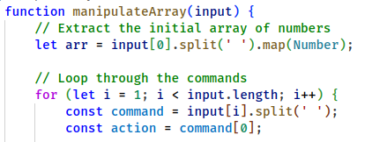
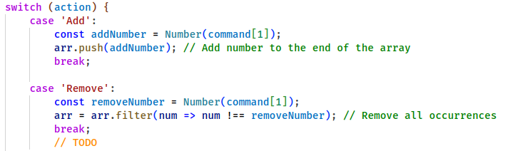
And finally:
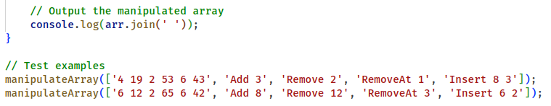

Judge Submission
Submit your code to the judge: https://alpha.judge.softuni.org/contests/arrays-strings-sets-maps-exercises/5280/.

Contact Book App
Implement (with AI) a "Contact Book" app to manage contacts.
- Use minimalistic HTML and JavaScript code
- Keep all contacts in a JS array, e.g.
let contacts = [
{name: "Peter", phone: "0888 999-111", email: "pp@yahoo.com", comments:"friend"},
{name: "Maria", phone: "0805 777-8888", email: "m@abv.bg", comments: ""},
…
];
- Implement [Add] / [Edit] / [Delete] contact, [Sort by Name], [Filter by Text]
- Add simple CSS styling for better look and feel
This is a sample of how the result may look like:
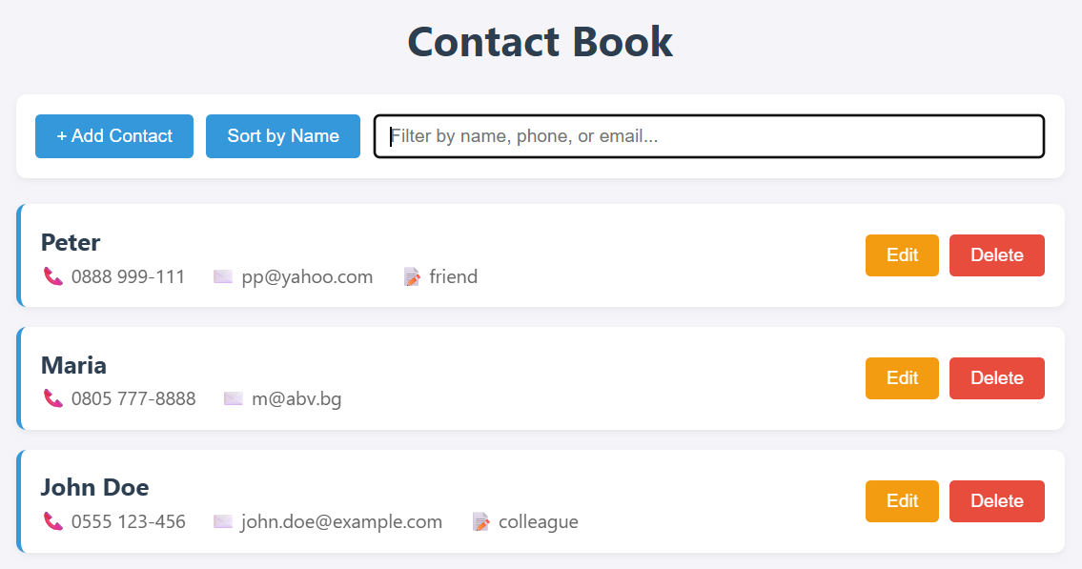
Explore the generated source code. Look at the JS code and how it uses arrays and array operations.

Polygon Editor on the Map

Part I: Polygon Editor
Implement (with AI) an interactive polygon editor (in HTML + CSS + JS), where users can create polygons by adding points on an interactive geographical map:
- Click on the map to add a point.
- View all existing points in a table, with [Remove], [Up] and [Down] buttons.
- Click [View as Array] to view the polygon as JSON array [{lat:…, lng:…}, {lat:…, lng:…}, …].
- Center the map in Sofia, Bulgaria.
This is a sample of how the result may look like:
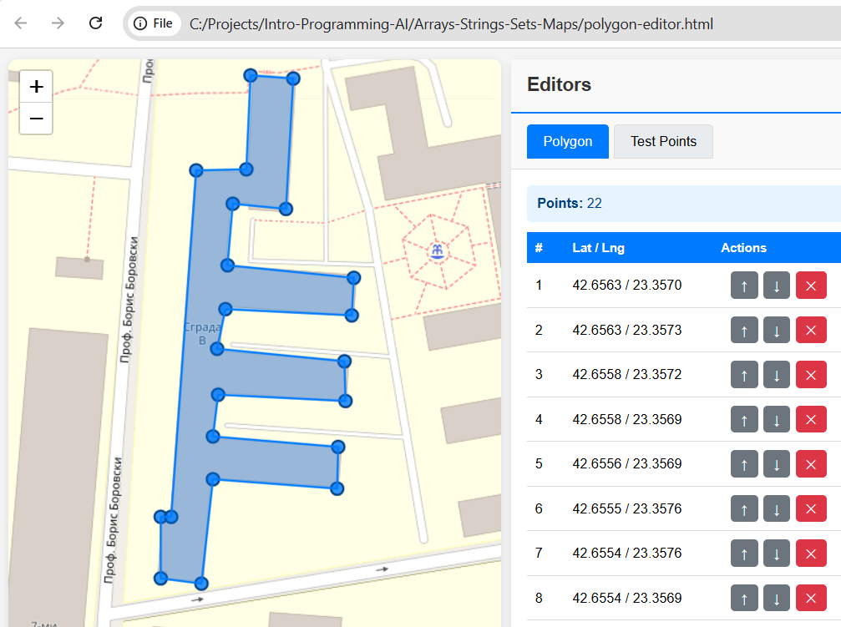

Part II: Point in Polygon
Add another editor (with AI): points on the map editor.
- Implement two tabs: [Polygon] for editing the polygon and [Test Points] for editing the test points.
- Click on the map to add a test point.
- Points are shown in a table, with [Remove] button.
- Points are visualized as green (inside the polygon) or red (outside of the polygon).
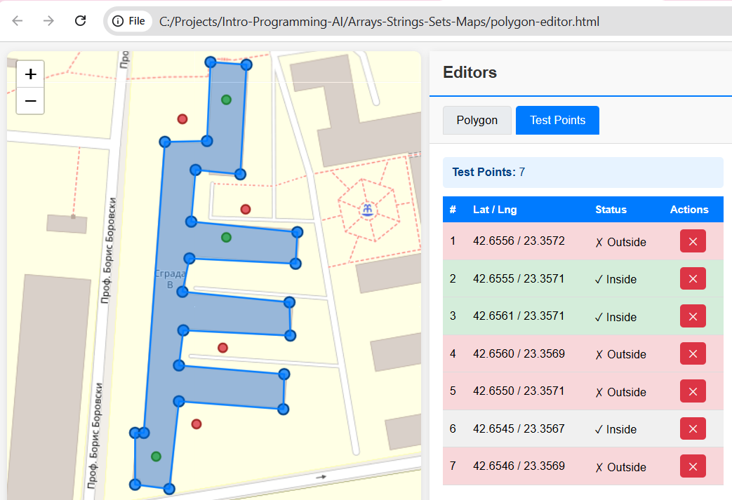
Explore the generated source code. Look at the JS code and how it uses arrays, maps and array operations.

Shortest Path in a Maze
Using HTML + CSS + JS, create a 2D maze editor (with AI):
- Select width + height (using a slider). This will create a rectangular grid (matrix).
- Click with the mouse to set each cell as "free" or "wall".
- Choose a start cell by clicking on the grid.
- Choose an end cell by clicking on the grid.
- Find the shorted path (if exists) and visualize it with arrows in the cells (left, up, down, right).
This is a screenshot of a sample implementation:
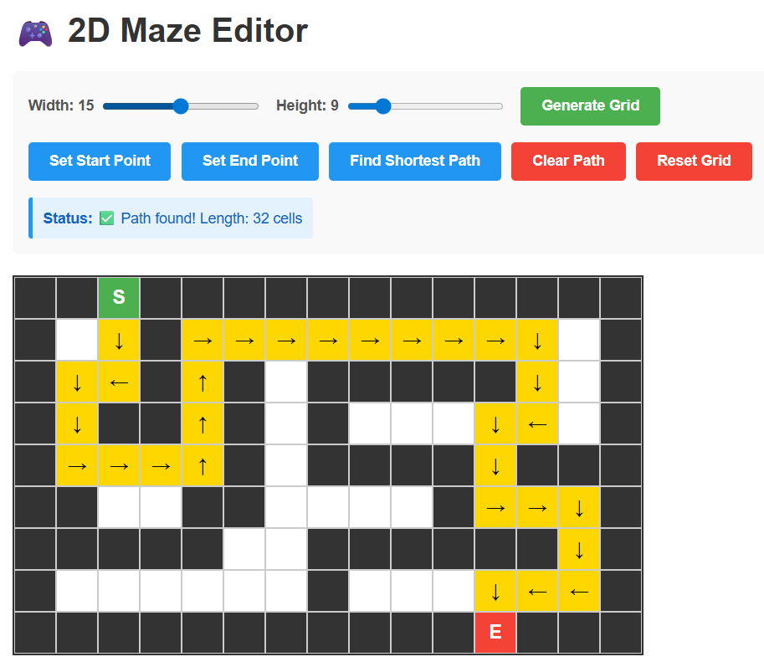

Sales Tracker
Using AI assistance, we want to implement a sales tracking app, based on HTML + CSS + JS.

Step 1: Implementing the Basic Layout
- Use minimalistic HTML and JavaScript code
- Use separate files for the HTML, CSS and JS code: sales-tracker.html, sales-tracker.css, sales-tracker.js.
- Implement 5 tabs: Product Editor, Price Editor, Locations, Sales, Reports
- Leave the tabs empty (put only headings inside)
- Use separate JavaScript file for the functionality in each tab
Run the app and check if it works as expected. Make changes when necessary.
This is screenshot of a sample implementation:
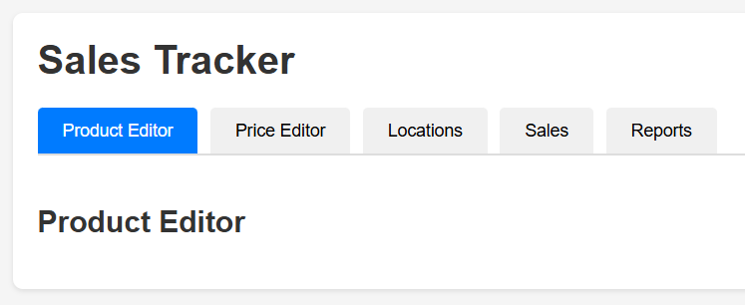

Step 2: Implementing the Data Layer
Use the following underlying data model:
let shop = {
products: ['bread', 'butter', 'eggs', 'yogurt'],
prices: { butter:5.30, eggs:0.40, bread:3.50, yogurt:1.65 },
locations: [
{ name:"Sofia", lat:42.657, lng:23.316, sales: [ ['bread',2],
['eggs',5], ['butter',1], ['bread',2], ['yogurt',2] ]},
{ name:"Plovdiv", lat:42.145, lng:24.779, sales: [ ['eggs',3],
['butter',2], ['bread',1], ['yogurt',4], ['bread',3] ] }
]
}
Generate more sample data.
Implement the following operations in the data layer:
- Implement add / edit / remove product. Update prices and sales data, when products change.
- Implement set product price. New products initially have no price assigned.
- Implement add / edit / remove location.
- Implement add / edit / remove sale in given location.
Look at the JS code: check if it is implemented as expected. Make changes when necessary.

Step 3: Implementing Product Editor
Implement the Product Editor in its tab.
- Show products in a table and implement add / edit / delete.
Run the app and check if it works as expected. Make changes when necessary.
- For example, when a product is deleted, look at the shop data to ensure it is properly updated and product is deleted from prices and sales.
This is screenshot of a sample implementation of the product editor:

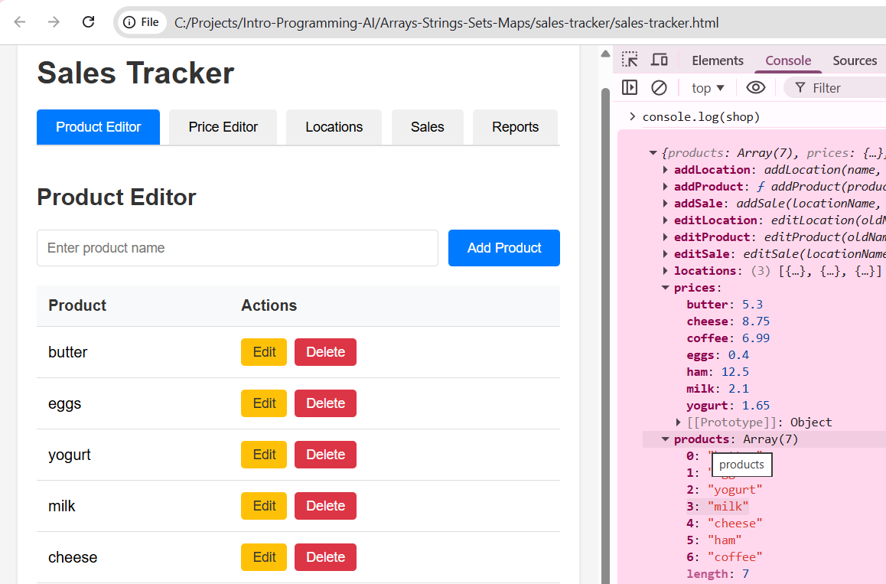

Step 4: Implementing Price Editor
Implement the Price Editor in its tab.
- Show products with their prices in a table and implement set price.
Run the app and check if it works as expected. Make changes when necessary.
This is screenshot of a sample implementation of the price editor:
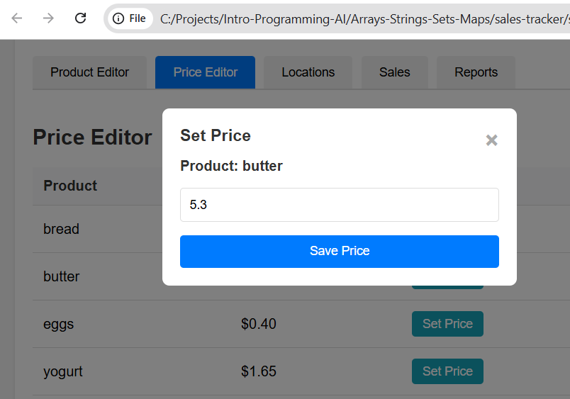

Step 5: Implementing Location Editor
Implement the Locations and Sales Editor in its tab.
- Show locations in a list on the left. Implement add / edit / delete location.
- When a location is selected, show its sales data on the right, as a table. Implement add / edit / delete sale.
Run the app and check if it works as expected. Make changes when necessary.
This is screenshot of a sample implementation of the location editor:
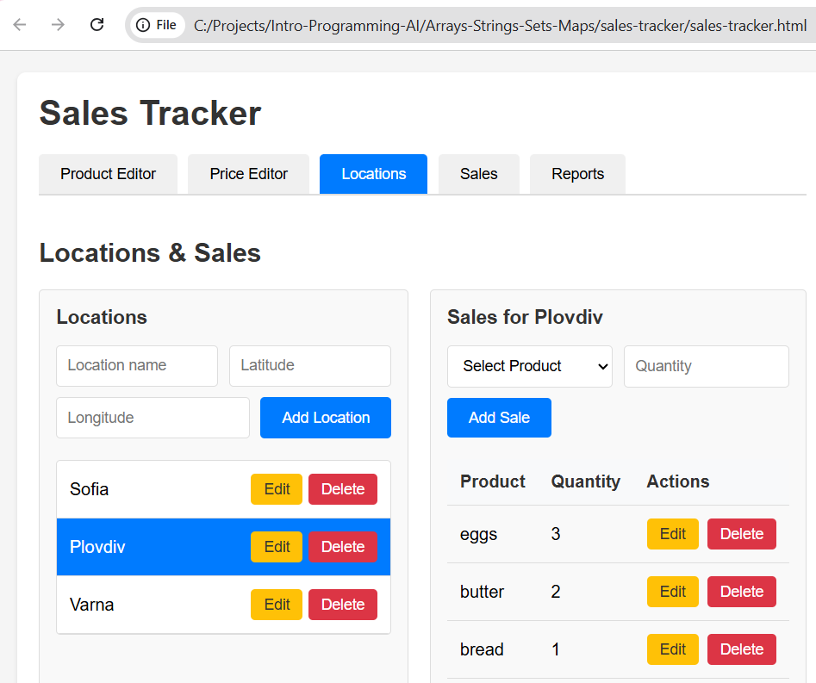

Step 6: Implementing Sales
Implement the Sales tab.
- Visualize all sales (for all locations) as a table: product, location, quantity sold, unit price, revenue.
- Add totals at the end of the tables.
- Implement column filtering and sorting.
Run the app and check if it works as expected. Make changes when necessary.
This is screenshot of a sample implementation of the "Sales" tab:
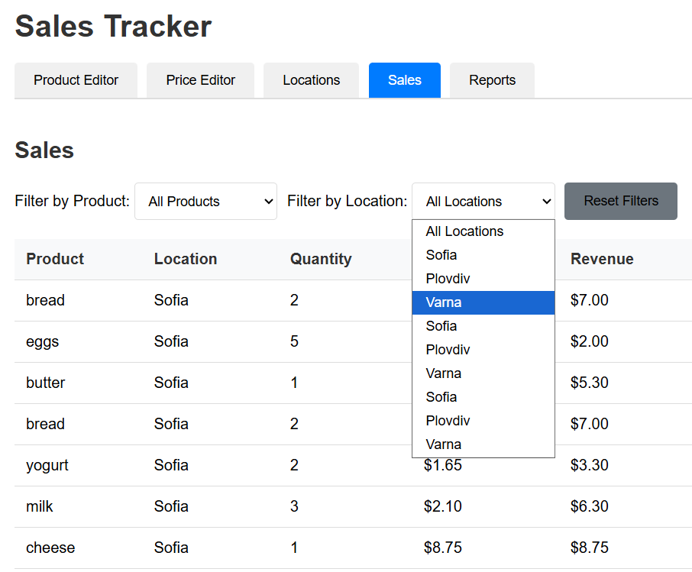

Step 7: Implementing Reports
Implement the Reporting in its tab.
- Visualize all locations and for each location the revenue per product.
  - Visualize the revenue as a table.
  - Visualize the totals for each location.
- Visualize the totals for all locations combined.
Run the app and check if it works as expected. Make changes when necessary.
This is screenshot of a sample implementation of the "Reports" tab:
